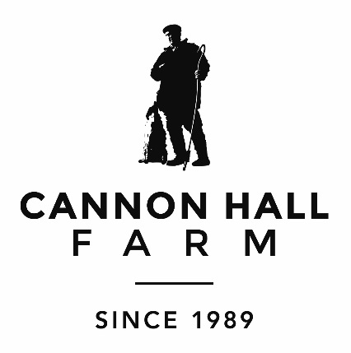
SCHOOLS PRICES -VALID UNTIL APRIL 2020
SOUVENIR PRICE LIST
Pencil & Eraser 95p
Pencil Set (Includes sharpener) £2.40
Pencil, Notebook & Eraser £1.95
Pencil Set (Includes sharpener & Eraser) £2.75
Notebook, Pencil Set (Includes Sharpener & Eraser) £3.75

ICE CREAM PRICE LIST

NUII- Vanilla £2.30
NUII- Mint £2.30
NUII Salted Caramel £2.30
DAIRY MILK £2.20
DAIRY MILK- Caramel £2.20
DAIRY MILK-Dai £2.20
CADBURY –Flake £2.20
NOBBLY BOBBLY £1.30
DEL MONTE-Real Lemonade £1.30

OREO Ice Cream £2.20
MOO MOO- Strawberry 90p
ROWNTREES – Randoms Mallo £1.00
ROWNTREES – Fruit Pastilles £1.30
ROWNTREES – Orange Push Up £1.30
ROWNTREES – Watermelon £1.30
ROWNTREES- Fruit Blaster £1.50
SMARTIES- Ice Cream £1.70
FAB £1.30

EXTREME- Salted Caramel & White Chocolate £2.00

ALL THESE ITEMS CAN BE PRE BOOKED
PLEASE CALL US ON 01226 790427 OR EMAIL bookings@cannonhallfarm.co.uk IF YOU WISH FOR ANY ITEMS TO BE ADDED TO THE INVOICE,
THANK YOU!

